GLEMSFORD PARISH COUNCIL IS PLEASED TO ANNOUNCE
EXCITING NEWS ABOUT OUR VILLAGE HALL
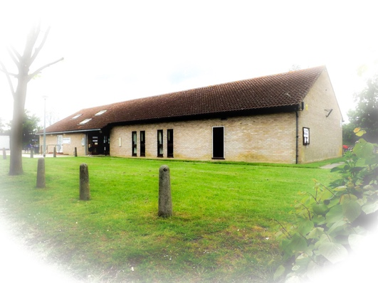

WE ARE PLANNING AN EXTENSION AND WOULD LIKE YOU TO BECOME PART OF THE DECISION MAKING PROCESS

On Saturday January 25th between 10 am and 4pm we invite you to a ‘drop in’ exhibition of our progress so far. You’ll be able to view and compare plans as they are now, with possible site and floor plans of the future. There’ll be photos and virtual models of the layout, both inside and out, for you to look at; and a cup of tea too, if you want one. The Architect will be on hand to answer your questions.

This stage in the planning is a ‘Feasibility Study’, so the ideas are not set in stone. There’s plenty of time to make changes and this is where you come in. As a ‘Hands On’ event the exhibition will give you the opportunity to think about and comment on anything from interior design, storage, and heating to roof shape and external appearance.

This improved and enlarged Community Centre will be a major asset for the Village. It can be anything you want. It can house all sorts of activities from amateur dramatics and ballroom dancing to wedding receptions and Zumba. It can house your Youth Group, your Crèche, your Lunch Club or your Physio. And you can be part of the plan. What we want to know is: what’s right for you? Do come along and tell us.

That’s Saturday 25th January, 10am to 4pm.

